GP Connector demo

<https://developer.nhs.uk/apis/gpconnect-1-2-7/>

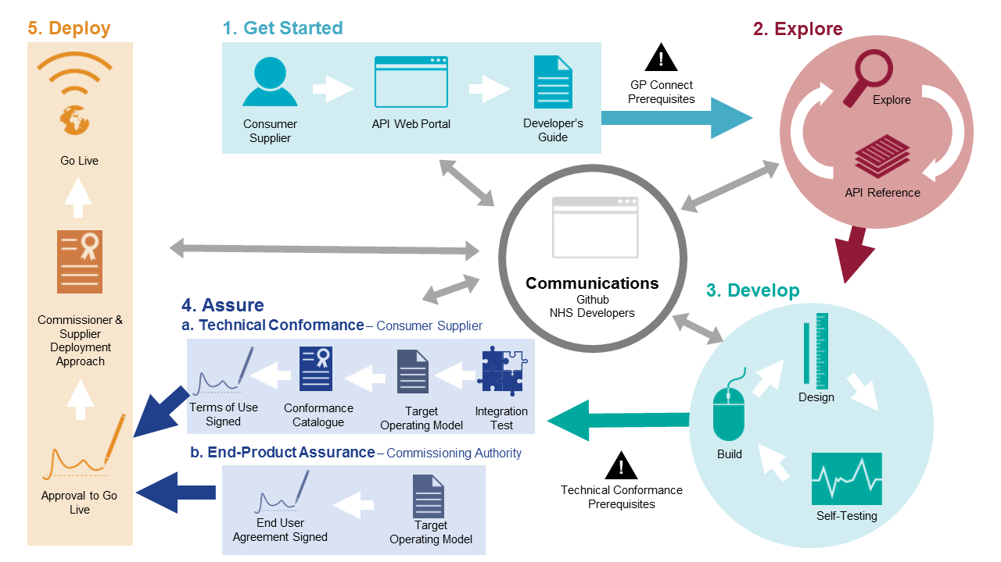

<https://digital.nhs.uk/services/gp-connect/gp-connect-specifications-for-developers>

<https://developer.nhs.uk/apis/gpconnect-1-2-7/overview_engage.html>

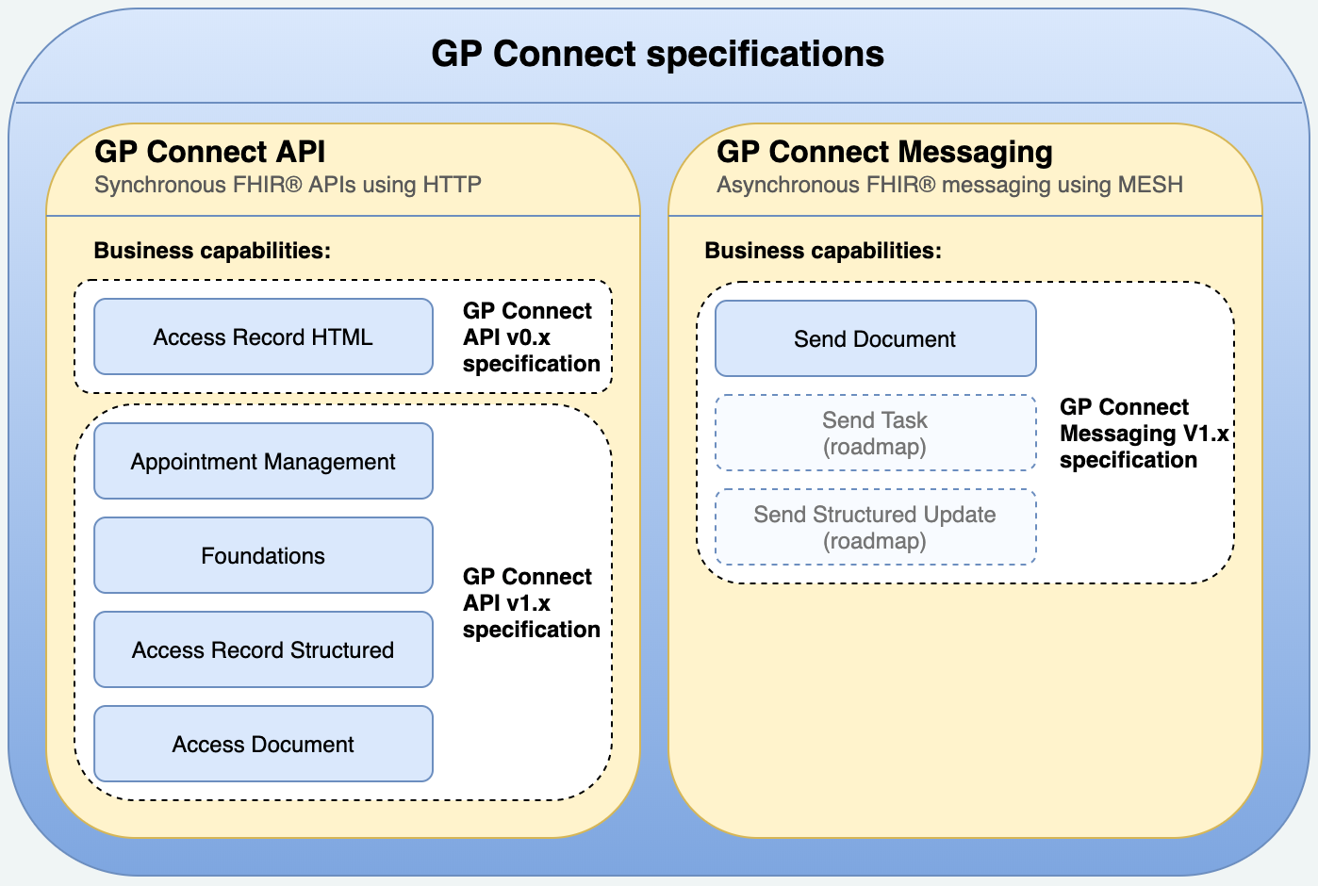

<https://orange.testlab.nhs.uk/>

<https://orange.testlab.nhs.uk/swagger-v1-appointments.html>

<https://orange.testlab.nhs.uk/swagger-v0.html>